1- An object moves according to the relation: 2vf = where (v) is velocity and (d) is displacement in meter. Find:

a) The initial velocity of the object.

b) The acceleration of its motion.

c- distance after 4 s

2- An object moves according to the relation: vf = where (v) is velocity and (d) is displacement in meter. Find:

a) distance after 4 s

3- Mohamed drove a car at uniform velocity (30 m/s). Suddenly, he saw a child crossing the street and he applied the brakes to decelerate the car uniformly at (9 m/s2). If Mohamed’s reaction time to use the brakes is (0.5s), find the displacement of the car till it stopped.

4- body was moving at uniform velocity 4m/s for 8 sec and then at acceleration 4m/s2 for 6 s Calculate the total distance

5- Car moves with velocity 30 m/s and after 5s its velocity becomes 10m/s calculate the distance covered by the car in the third second.

6- A body is moving according to this relation : t , so the velocity after 4 s is

s b) 3 s c) 4m/s d) 12m/s

1. A train of length 100 m enters a straight tunnel of length 1 km with a velocity of 4 m/s. If the train is moving by acceleration 0.5 m/s, then the required time for the entire train to leave the tunnel is .....

A) 550 s b) 58.81 s c) 20.31 s d) 20 s

V2

1. The opposite graph describes the motion 15

of a body moving by a uniform acceleration, 10

so the acceleration of this body equals 5

1. 8 m/s2 b)4 m/s2 c) 2.5 m/s2 d) I m/s2 1 2 3 d
2. A stone falling down from height 90m if g = 10 m/s2 find its final velocity and the height.
3. An object falls from 5 m high above the ground. Find its velocity when reaching the ground and the time taken. (g = 10 m/s2)
4. An object is projected at an angle of 30 to the horizontal and returns to the earth’s surface after 4 s, then the initial velocity by which the object is projected equals……… m/s

a) 60 b) 40 c) 35 d) 20

1. A ball is projected from the earth’s surface with velocity of 20 m/s at an angle of 60 to the horizontal then the maximum height reached by the ball is…… m

a) 0.866 b) 5 c) 15 d) 30

1. If an object is projected upwards at an angle of 30 to the horizontal and its initial velocity is 20 m/s, so the maximum height reached by the object is………….m

a) 5 b) 10 c) 15 d) 20

1. If the body projected by velocity make angle with horizontal , if Viy = 4vix

So the angle between them is ……………..

1. 30 b) 45 c) 76 d) 63.4
2. When an object is projected at initial velocity in a direction making an angle60° to the horizontal to reach a horizontal range R. To make the projectile reach a greater range, it should be projected at the same initial velocity and angle ....................
3. a) 90º b) 75º c) º45 d) 30º
4. body projected by initial velocity Vi make angle 45 with horizontal to cover horizontal range 100m , if the body projected by same initial velocity , it will projected By angle 60 the horizontal range may be …………….m
5. 100 b) 150 c) 70 d) 120
6. The horizontal displacement reached by two identical projectiles in the same when they are projected at the same initial velocity from the same point at angles…………

a) 80 and 10 b) 30 and 50 c) 80 and 20 d) 80 and 30

1. body projected by initial velocity Vi make angle 40 with horizontal to cover horizontal range 100m , to cover same range by same initial velocity , it will projected By angle …………….
2. 30 b) 50 c) 70 d) 10
3. body projected by initial velocity Vi make angle 45 with horizontal to cover horizontal range 100m and maximum height 25m , if the body is projected by angle 60 so the horizontal range is ……………………and maximum height ………………………
4. increase – decrease
5. increase – increase
6. decrease – increase
7. decrease – decrease
8. **which graph has large acceleration 1 or 2?** **And why?** v

**1**

**2**

t

1. **from the following graph find ratio between acceleration of A and B?**

**v**

A B

**40**

**40**

**t**

23- Choose V

1) the opposite graph represents the relation

between the displacement (d) and the time (t)

for a car that moves in straight lineso in which

period the acceleration of the car greatest

a b c d t

a) period ab

b) period bc

d) period cd

1. Two boxes are dropped from a static balloon, the first one is dropped when the distance between the balloon and the earth’s surface was (H) and the second one when the distance was (4H), calculate the ratio between the time taken by the box to reach the earth’s surface in the second case and the time taken by it in the first case

24- The places of two X and Y cars have been represented at successive intervals of 1 second in numbered shapes in the bottom shape. As thought The direction of movement of the two cars to the right.



Which of the following phrases correctly describes the movement of the two cars?

A. The two vehicles move at an irregular speed.

B. The car moves X at regular speeds, while the Y-car moves in a regular acceleration

C. The X-car moves with an irregular acceleration , while the Y-car moves at regular speeds.

D. The X-car moves in a regular acceleration , while the Y-car moves at regular speeds.

1. Study the following graphs then answer:

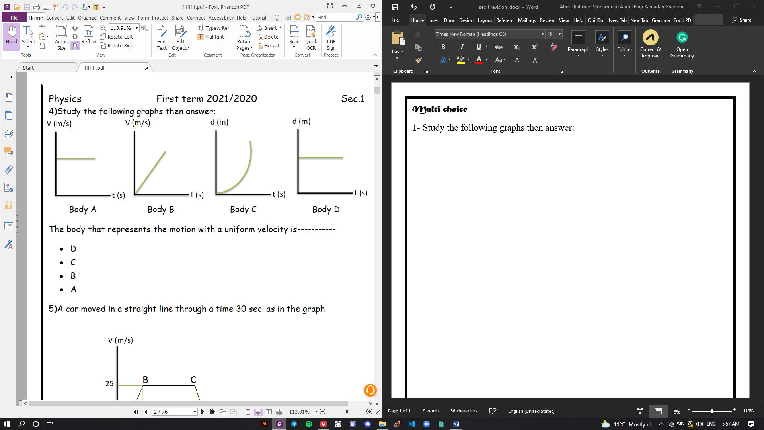

The body that represents the motion with a uniform velocity is………

1. D b) C c) B d) A
2. 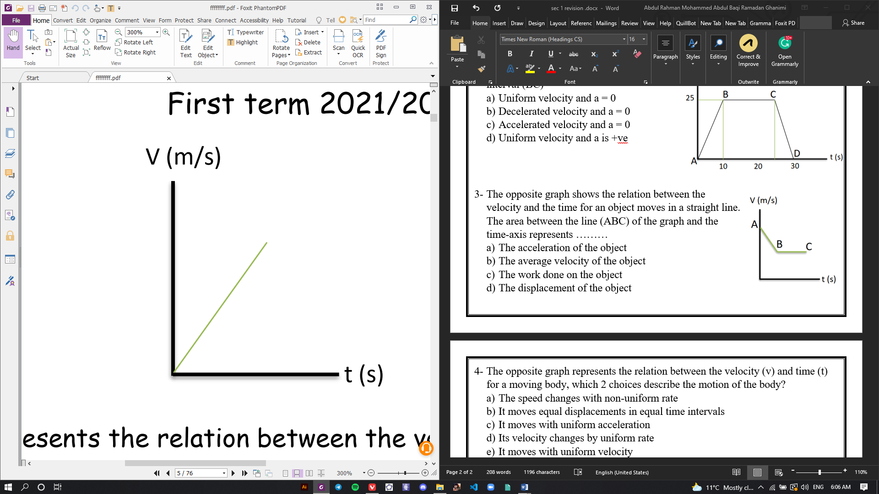The opposite graph represents the relation between the velocity (v) and time (t) for a moving body, which 2 choices describe the motion of the body?
3. The speed changes with non-uniform rate
4. It moves equal displacements in equal time intervals
5. It moves with uniform acceleration
6. Its velocity changes by uniform rate
7. It moves with uniform velocity
8. In the opposite graph, the acceleration of the object is equal to……. m/s2
9. 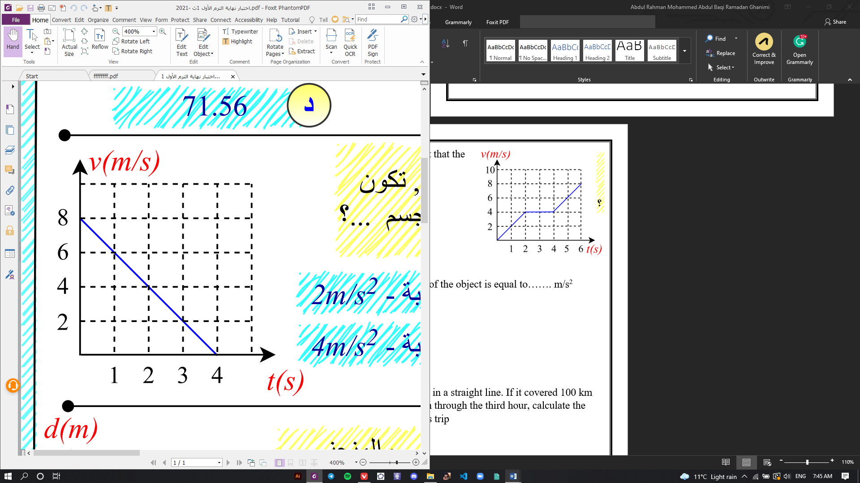-2
10. 2
11. 4
12. -4
13. 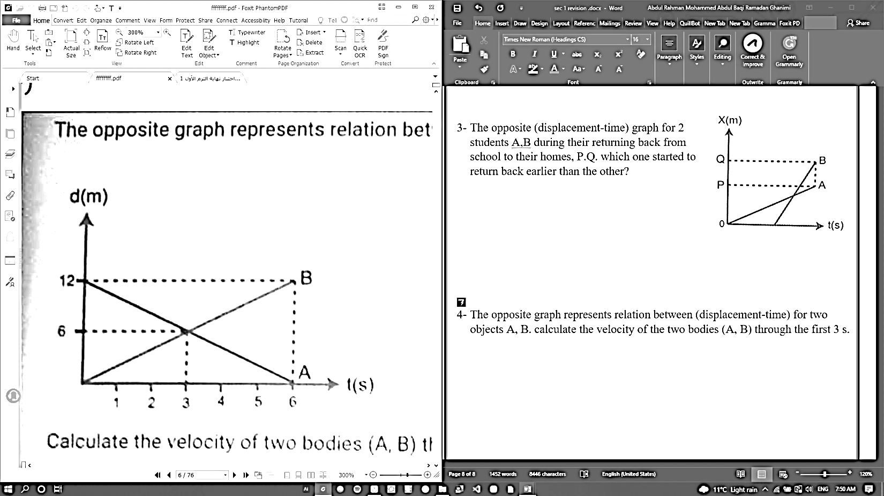 The opposite graph represents relation between (displacement-time) for two objects A, B. calculate the velocity of the two bodies (A, B) through the first 3 s.
14. Two models represent covered displacement of two different bodies. What is the type of velocity of each body?

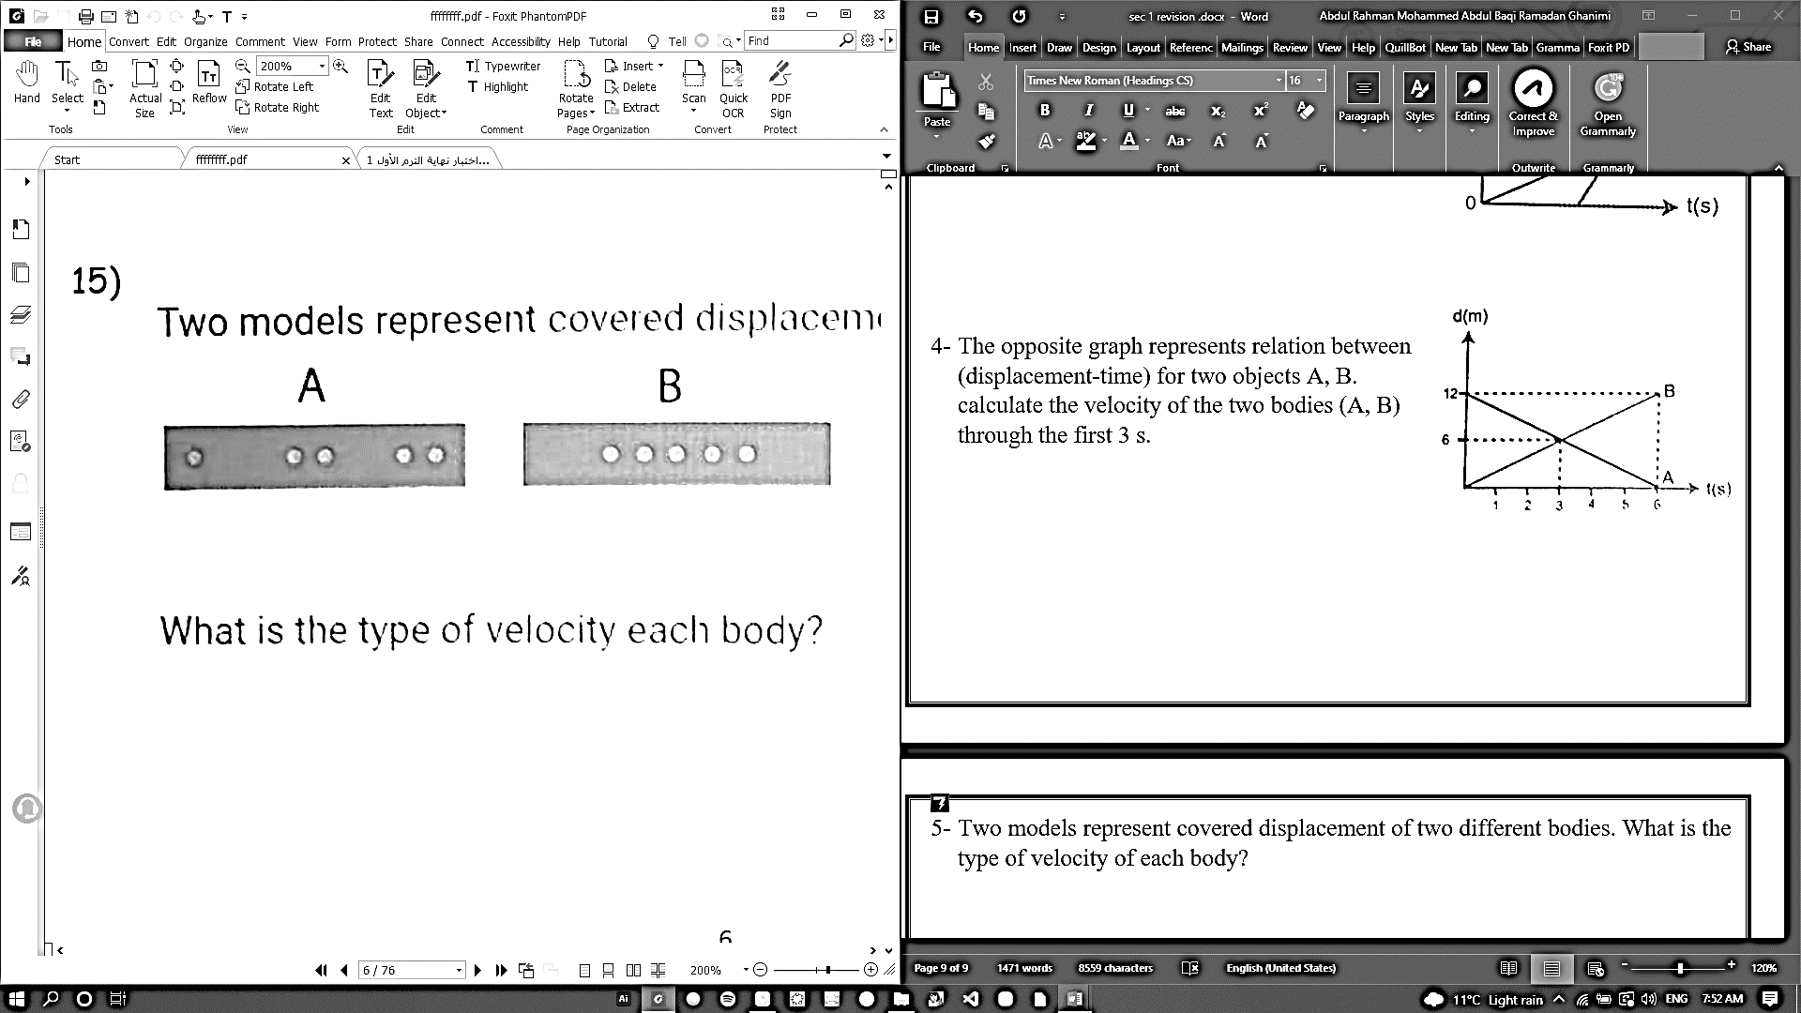

1. **The opposite graph illustrates the motion of an object that started its motion from rest with a uniform acceleration, so the acceleration, so the acceleration of its motion is…………**

**D (m)**

**t (s)**

**40**

**4**

1. **5 m/s2**
2. **4 m/s2**
3. **10 m/s2**
4. **5 m/s2**
5. 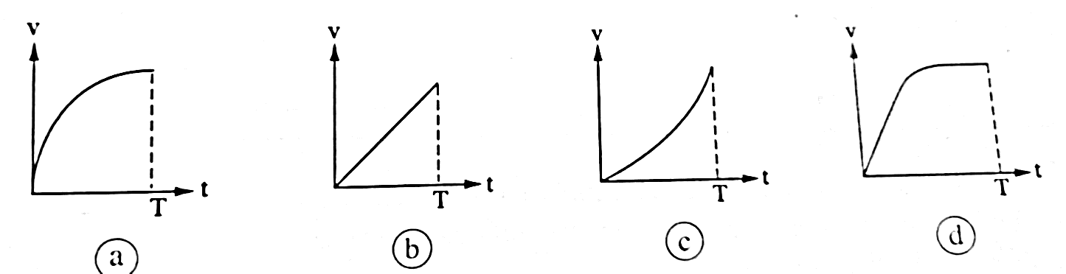**A body falls freely from the top of a building and reaches the ground after time (T), if the resistance of air is neglected, which of the**

**following figures represents the change of its velocity with time?**  ‘

1. 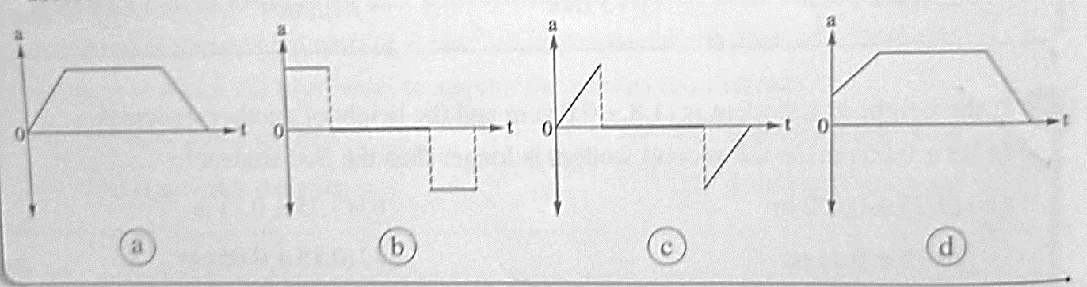**A car starts its motion from rest with a uniform acceleration until its velocity reaches (v) then it continues its motion with uniform velocity for a while before the driver applies the brakes to decrease its velocity uniformly till it stops, which of the following graphs describes the motion of the car accurately?**
2. if body (x) acting on another body (y) by force of 9 N, then the reaction force of body y on body x equals…………

a) 1 N b) 0 N c) 9 N d) – 9 N

1. A car of mass 1000kg moves with a uniform velocity of 12 m/s to the east

The resultant force acting on the car is …………….N

1. 12000 b) 1200 c) 1012 d) 0
2. the opposite figure illustrate the (d-t) graph

for object of mass 2-kg , so the resultant force d

acting on it is ……………….. 10

1. 100 N b) 200N

c)102N d) 0

1. t
2. The body is equilibrium when …………….
3. The resultant of the forces that acts on it equals zero
4. It is static
5. It moves with uniform velocity in straight line
6. All the pervious
7. A car is moving on horizontal road with a uniform velocity of 10m/s is affected by frictional force of 1500 N , so the force by which the engine acts on the car is ….
8. 150N b)1500N C) 15000N d) 0
9. The opposite figure shows the collision of the two bodies X and Y which have masses of m and 4 m respectively. If the body X acts on the body Y during the collision by force F. then the body Y acts on the body X by force

X Y

1. F b) 1/4F C) 4F d) –F
2. If the Earth acts on you while your motion by 600 N In your body acts on the Earth by force of ……………….
3. Zero b) 300N C) 600 N D) 1200N